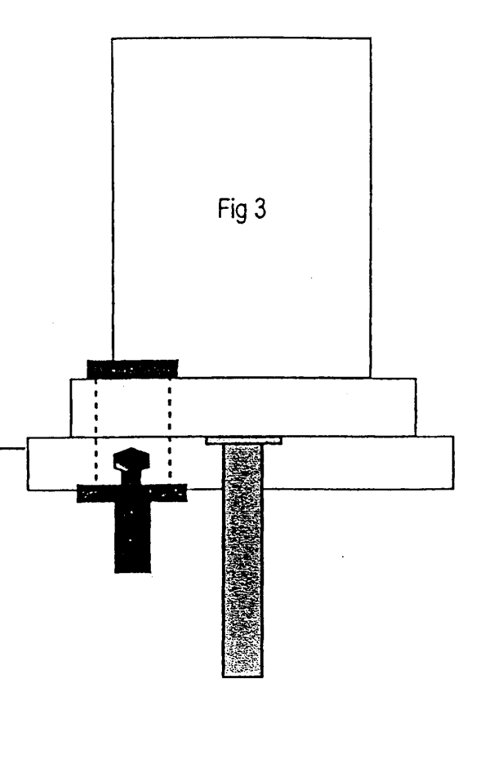

Headstone
plate

Headstone base
Stainless steel lockdown sleeve
Foundation

Stabilization tube

Picture above shows an cross section example of the NAMM approved Blast Shop Stainless steel bolting fixing method, the foundations we us are much wider normally being 36” x 18” x 3” and are glass fibre reinforced concrete.
None of the fixings are seen once the memorial is fixed the flower container sits in to the lockdown sleeve and can be positioned Left, Right or Centre, the stabilization tube is under the memorial base and the headstone plate is bolted to the headstone base.
If you require any further reassurance to the method and reasons we fix to the most up-to- date safety standards please do not hesitate to contact us.

